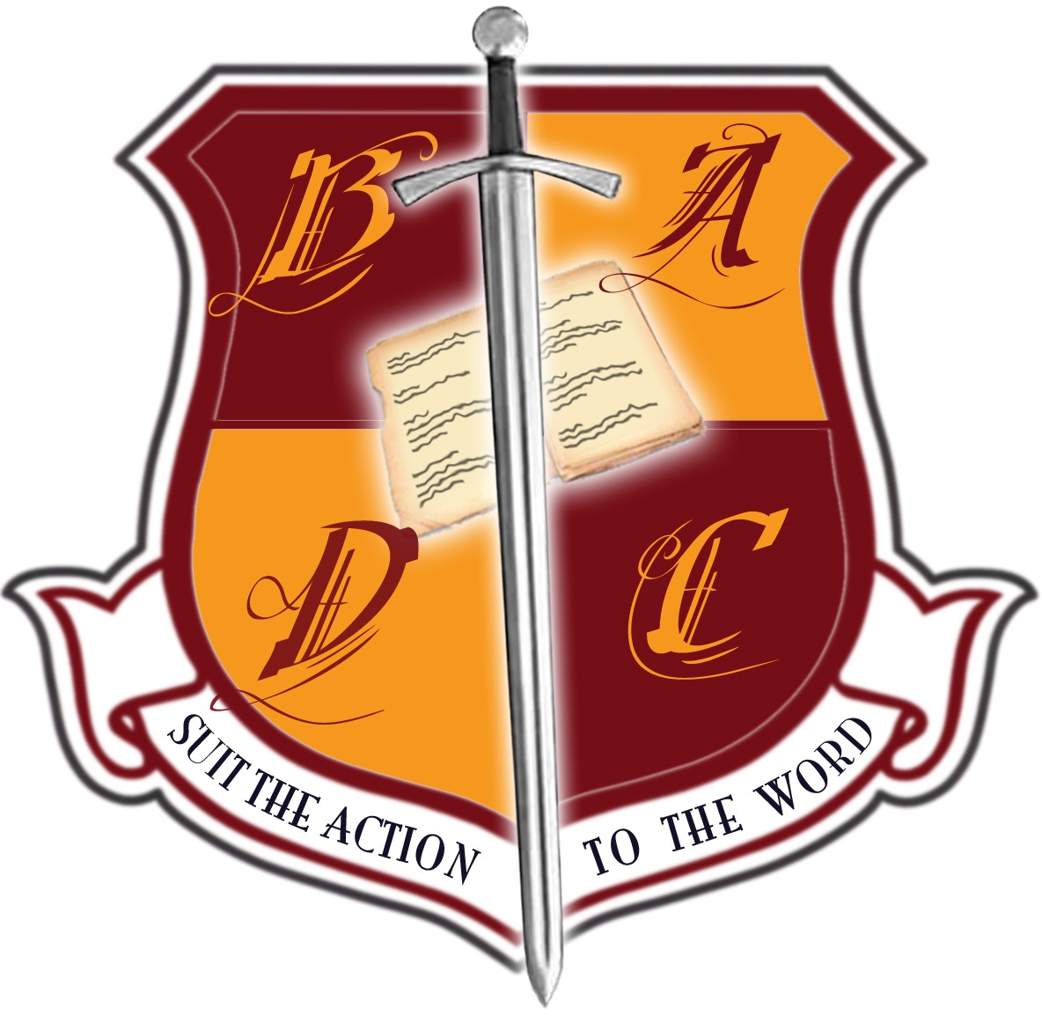
BRITISH ACADEMY OF DRAMATIC COMBAT

New Syllabus Proposal Form

Please use this form if you would like to propose a syllabus for a new weapon system to be considered for use with BADC examinations. Complete the sections below using word processed text or print the form and complete in clearly legible handwriting. Once all sections have been completed, the form should be sent to the BADC Committee as an email attachment to: info@badc.org.uk (for postal submissions please email for address).

NB: Only weapon systems which have a syllabus that has been approved and validated by the BADC Committee may be used in BADC Examinations.

- Name of Weapon System
[Provide specific title of the weapon system to be studied]

Recommended type/make of weapon to be employed
- Rationale
[Provide a rationale for the inclusion of the weapon system as a BADC syllabus giving information regarding the relevance of the system to performance combat training and the prevalence of the system’s use in theatre, television, film or other media]
- Background information
[Provide a short introduction to the weapon system giving information about the historical and cultural contexts of its use]
- Level of Syllabus
[Indicate the level at which the weapon system is to be examined by ticking all applicable boxes]

□ Foundation
□ Level 1
□ Level 2
□ Advanced (ASW)
□ Single Weapon Specialization
- Reasons for choice of level(s)
[Provide a short statement to explain the level/s proposed]
- Techniques
[Provide a detailed breakdown of the specific techniques to be covered under the following headings:]

- Posture/ stance/ form

- Engarde/s

- Footwork

- Grip

- Targets

- Cutting/thrusting drills (if applicable)

- Attacks to the body (Strikes to all target on all lines)

- Attacks to the weapon (e.g. prise de fer)

- Parries/Blocks

- Avoidance’s

- Corps á corps

- Disarms,

- Floor work (e.g. rolls)

- Wounds and Kills

- Other
      - Teaching Notes
[Provide additional information about the teaching of specific techniques and variations where applicable. Include information sources such as historical texts where available, bibliography, filmography and websites if appropriate]
      - Health and Safety
[Provide additional information regarding specific health and safety issues related to the teaching and practice of the proposed weapon system]

© British Academy of Dramatic Combat, December 2007

